**Activity 1: Create a mysql/postgres rds with 2 days auto backup**

* Create an rds single instance db  
  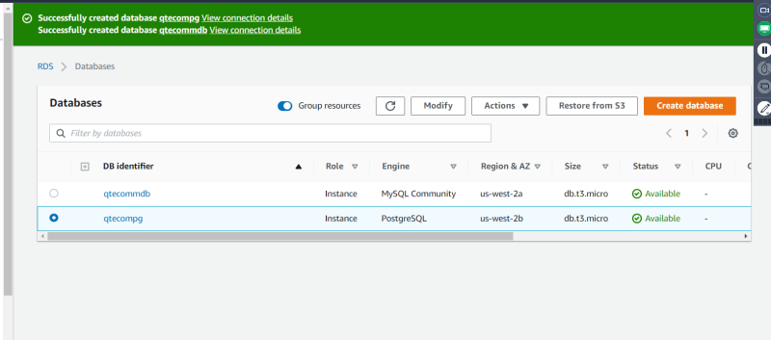
* Insert some data into the database
* To insert postgres sample data <https://github.com/vrajmohan/pgsql-sample-data/tree/master/employee>
* To take the manual backup, create snapshot  
  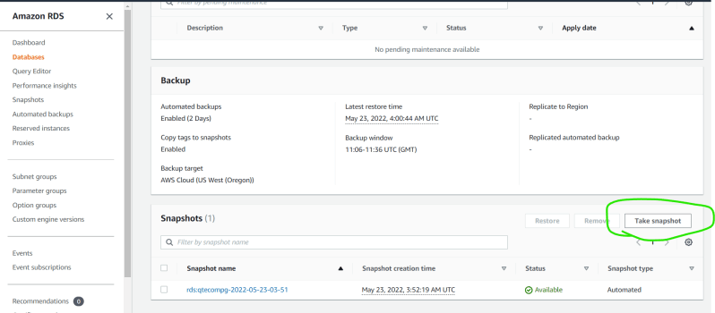  
  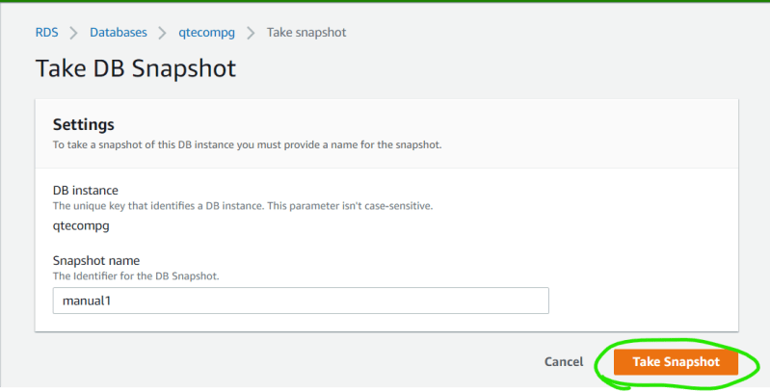  
  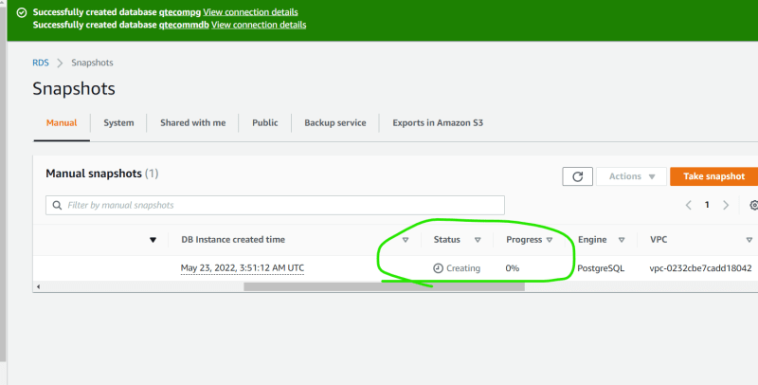  
  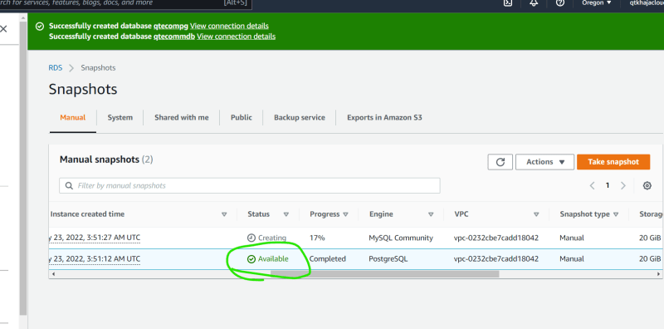
* The actions that can be done with this backup are  
  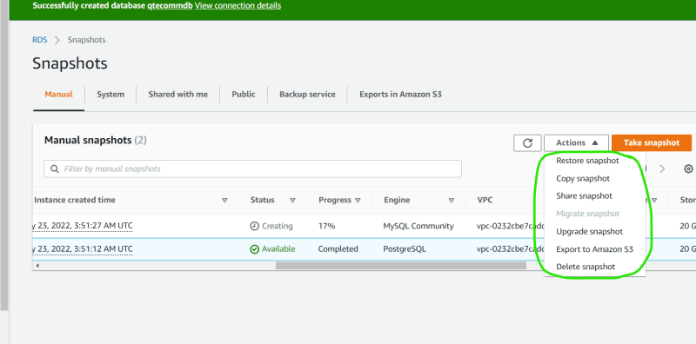
* Lets export the snapshot to s3  
  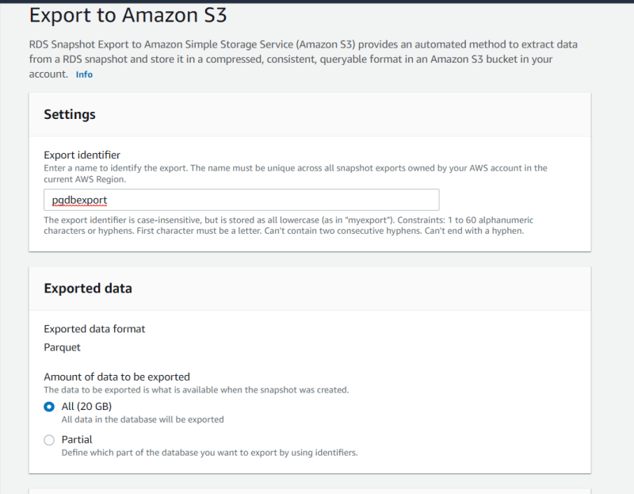  
  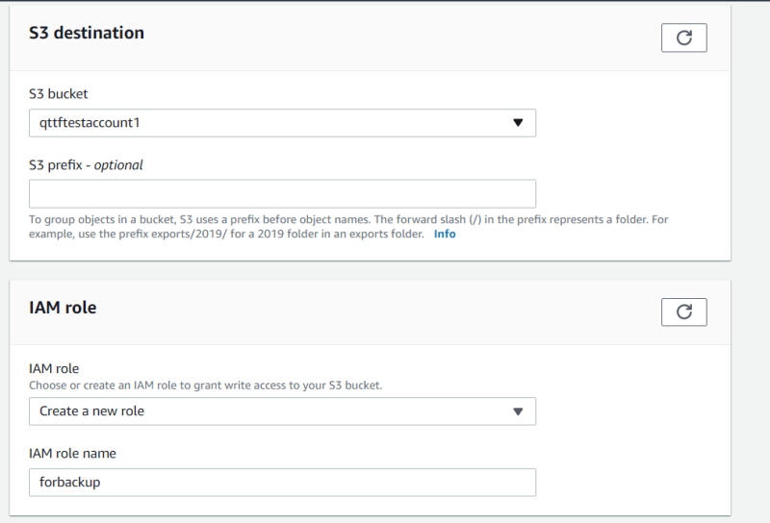  
  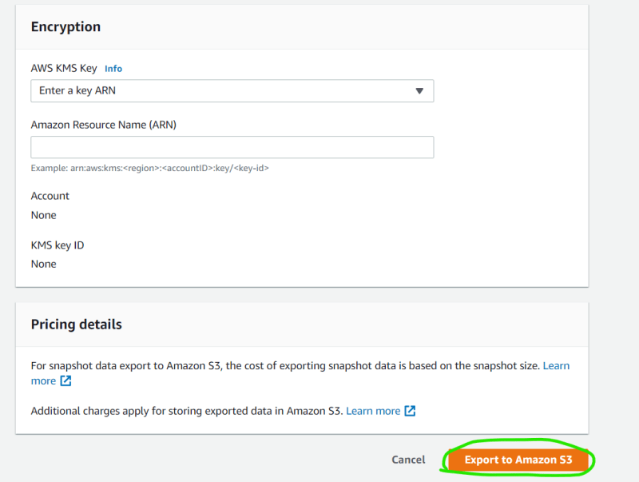
* Copy snapshot allows to copy the database backup to any region
* Restoring from snapshot allows us to create the database.
* While Creating the account we have configured for two days backup  
  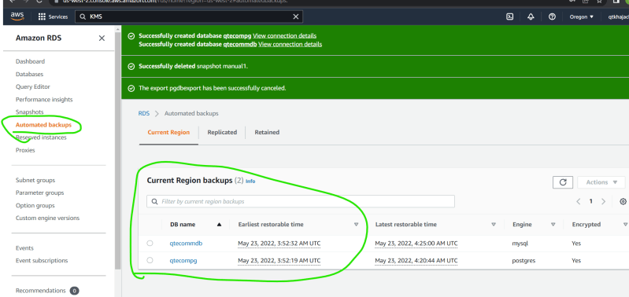
* Now lets open AWS Backup Service as this is one stop solution for taking backups for different AWS Services  
  